Sorting instructions

Bins
Organic matter rotates from one bin to another.
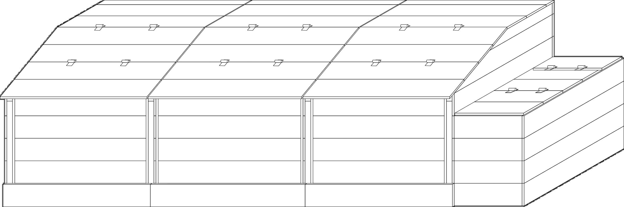
1
2
3

Deposit bin
We deposit in the current deposit bin (bin 1), mentioned by a sign.

Maturation bin and distribution

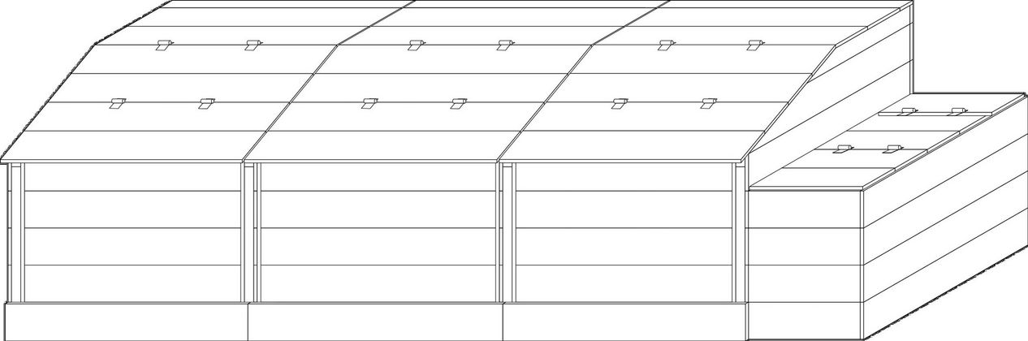
Distribution
When bin 1 is full, the compost from bin 3 is distributed (compost has a woody smell and a dark brown color).
We pass the content of bin 2 into bin 3,
We transfer the content from bin 1 to bin 2 to begin maturation.
Bin 1 remains the one of the deposit, we do not deposit anything in the others.
The rotations allow to ventilate and thus activate the living things (bacteria, fungi, bugs...)
that will finish the job.

Code
The padlock code is 2222.

Deposit
Compostable | Unauthorized deposit
-Peelings (cut into pieces)  -Fruits, including citrus fruits (cut into pieces)  -Egg shells (crushed)  -Coffee grounds, coffee filters, tea bags  -Bread (soaked in water) | -Animal remains (Meat, fish, bones, shells, etc.)  -Cores (fruit, olive, avocado…)  -Garden waste (grass, branch, etc.)  -Paper / cardboard  -Plastic, including "compostable" plastic bag (too long to decompose)

Permanence
During the Saturday morning from 11 a.m. to 12 p.m., we remind you of the sorting instructions.
Tools are on site with which we:
- spread the materials deposited so as not to have agglomerates that decompose badly.
- cover the deposits with a few shovels of dry sawdust.

